K2 Update Datafields Application

**Note: Please make sure that there is a database backup made prior to executing the application, in case of unforeseen circumstances.**

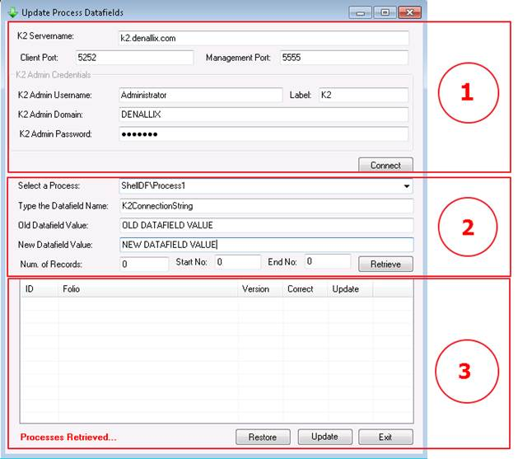

1. **Enter the following information:**

K2ServerName

Client Port and Management Port *(****Default*** *ports are entered automatically)*

K2 Administrator Username

K2 Administrator Label *(****Default*** *label are entered automatically)*

K2 Administrator Domain

K2 Administrator Password

Click on **Connect** to retrieve all the processes on your system.

1. **Enter the following information:**

Select the **Process** you want to update from the dropdown list

Enter the **Datafield Name** you want to update

**Old Datafield Value** (This is to make sure to only update process instances that have the old value)

**New Datafield Value** (The value you want to update to)

Num of Records (**0** returns all ProcessInstances, any other number will return that amount of instances)

Start No (You can specify a start Process Instance number – This is when doing batch updates of a certain number, leave on 0 to start at beginning)

End No (You can specify an end Process Instance number – This is when doing batch updates of a certain number, leave on 0 to end at last instance)

Click on **Retrieve**

**PLEASE NOTE: This might take a few minutes to retrieve depending on any number of factors, use BareTail to monitor the progress using the logs generated.**

1. Click on **Update**

**use BareTail to monitor the progress using the logs generated.**

Use the following **SQL query** after you have successfully updated all the instances to determine if there are still any left that still needs attention, I believe that there should be none.

SELECT * FROM [K2].[ServerLog].[ProcInstData] AS [PID]

INNER JOIN [K2-PRD].[Server].[ProcInst] AS [PI]

ON [PID].[ProcInstID] = [PI].[ID]

WHERE [ProcID] IN (474)

AND [PID].[Name] = '[DATAFIELDNAME]'

AND [PID].[Value] like '[OLD_DATAFIELD_VALUE]'

AND [PI].[Status] IN (0, 1, 2)

ORDER BY [PI].[ID] DESC